Factor Analysis

Notes
Output Created |  | 28-JUN-2021 14:15:17
Comments
Input | Data | /Users/coderlax/Desktop/EO Hackathon/Asia/Quality of Life/COVID/Zscore/Z2.sav
Input | Active Dataset | DataSet7
Input | Filter | <none>
Input | Weight | <none>
Input | Split File | <none>
Input | N of Rows in Working Data File | 12
Missing Value Handling | Definition of Missing | MISSING=EXCLUDE: User-defined missing values are treated as missing.
Missing Value Handling | Cases Used | LISTWISE: Statistics are based on cases with no missing values for any variable used.
Syntax |  | FACTOR  /VARIABLES ZAir ZWater  /MISSING LISTWISE  /ANALYSIS ZAir ZWater  /PRINT UNIVARIATE INITIAL CORRELATION KMO EXTRACTION ROTATION  /FORMAT SORT  /PLOT EIGEN  /CRITERIA FACTORS(2) ITERATE(25)  /EXTRACTION PC  /CRITERIA ITERATE(25)  /ROTATION VARIMAX  /METHOD=COVARIANCE.
Resources | Processor Time | 00:00:00.17
Resources | Elapsed Time | 00:00:01.00
Resources | Maximum Memory Required | 1176 (1.148K) bytes

Descriptive Statistics
 | Mean | Std. Deviation | Analysis N
ZAir | 1.4262917 | 1.00000044 | 12
ZWater | 1.1037283 | .99999951 | 12

Correlation Matrix
 |  | ZAir | ZWater
Correlation | ZAir | 1.000 | .511
Correlation | ZWater | .511 | 1.000

KMO and Bartlett's Testª
Kaiser-Meyer-Olkin Measure of Sampling Adequacy. |  | .500
Bartlett's Test of Sphericity | Approx. Chi-Square | 2.875
Bartlett's Test of Sphericity | df | 1
Bartlett's Test of Sphericity | Sig. | .090

a. Based on correlations

Communalities
 | Raw |  | Rescaled
 | Initial | Extraction | Initial | Extraction
ZAir | 1.000 | 1.000 | 1.000 | 1.000
ZWater | 1.000 | 1.000 | 1.000 | 1.000

Extraction Method: Principal Component Analysis.

Total Variance Explained
 | Component | Initial Eigenvaluesª |  |  | Extraction Sums of Squared Loadings
 | Component | Total | % of Variance | Cumulative % | Total | % of Variance | Cumulative %
Raw | 1 | 1.511 | 75.550 | 75.550 | 1.511 | 75.550 | 75.550
Raw | 2 | .489 | 24.450 | 100.000 | .489 | 24.450 | 100.000
Rescaled | 1 | 1.511 | 75.550 | 75.550 | 1.511 | 75.550 | 75.550
Rescaled | 2 | .489 | 24.450 | 100.000 | .489 | 24.450 | 100.000

Total Variance Explained
 | Component | Rotation Sums of Squared Loadings
 | Component | Total | % of Variance | Cumulative %
Raw | 1 | 1.000 | 50.000 | 50.000
Raw | 2 | 1.000 | 50.000 | 100.000
Rescaled | 1 | 1.000 | 50.000 | 50.000
Rescaled | 2 | 1.000 | 50.000 | 100.000

Extraction Method: Principal Component Analysis.
a. When analyzing a covariance matrix, the initial eigenvalues are the same across the raw and rescaled solution.

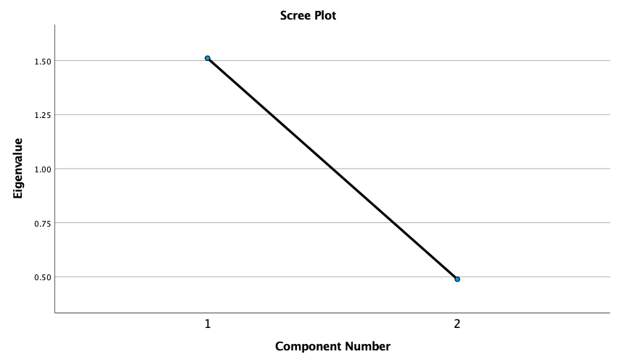

Component Matrixª
 | Raw |  | Rescaled
 | Component |  | Component
 | 1 | 2 | 1 | 2
ZAir | .869 | -.494 | .869 | -.494
ZWater | .869 | .494 | .869 | .494

Extraction Method: Principal Component Analysis.ª
a. 2 components extracted.

Rotated Component Matrixª
 | Raw |  | Rescaled
 | Component |  | Component
 | 1 | 2 | 1 | 2
ZWater | .964 | .265 | .964 | .265
ZAir | .265 | .964 | .265 | .964

Extraction Method: Principal Component Analysis.
Rotation Method: Varimax with Kaiser Normalization.ª
a. Rotation converged in 3 iterations.

Component Transformation Matrix
Component | 1 | 2
1 | .707 | .707
2 | .707 | -.707

Extraction Method: Principal Component Analysis.
Rotation Method: Varimax with Kaiser Normalization.

